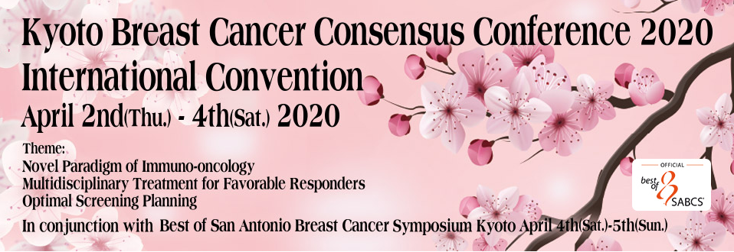
Travel Grant Application Form
Print and complete hard copy. Either fax back or scan and email PDF

Family Name: _ _ _ _ _ _ _ _ _ _ _ _ _ _ _ _ _ _ _ _ _ Given Names: _ _ _ _ _ _ _ _ _ _ _ _ _ _ _ _ _ _ _ _ _ _ _
Employment/Research Position: _ _ _ _ _ _ _ _ _ _ _ _ _ _ _ _ _ _ _ _ _ _ _ _ _ _ _ _ _ _ _ _ _ _ _ _ _ _ _ _ _ _
Organization: _ _ _ _ _ _ _ _ _ _ _ _ _ _ _ _ _ _ _ _ _ _ _ _ _ _ _ _ _ _ _ _ _ _ _ _ _ _ _ _ _ _ _ _ _ _ _ _ _ _ _ _
Department/Division: _ _ _ _ _ _ _ _ _ _ _ _ _ _ _ _ _ _ _ _ _ _ _ _ _ _ _ _ _ _ _ _ _ _ _ _ _ _ _ _ _ _ _ _ _ _ _ _
Address: _ _ _ _ _ _ _ _ _ _ _ _ _ _ _ _ _ _ _ _ _ _ _ __ _ _ _ _ _ _ _ _ _ _ _ _ _ _ _ _ _ _ _ _ _ _ _ _ _ _ _ _ _ _
City/Town: _ _ _ _ _ _ _ _ _ _ _ _ _ _ _ _ _ _ _ _ _ _ _ _ _ _ _ _ _ Zip/Postcode: _ _ _ _ _ _ _ _ _ _ _ _ _ _ _ _ _
Country: _ _ _ _ _ _ _ _ _ _ _ _ _ _ _ _ _ _ _ _ __ _ _ _ _ _ _ _ _
Work phone number (include International Code) _ _ _ _ _ _ _ _ _ _ _ __ _ _ _ _ _ _ _ _ _ _ _
Work fax number: _ _ _ _ _ _ _ _ _ _ _ _ _ _ _ _ _ Email address: _ _ _ _ _ _ _ _ _ _ _ _ _ _ _ _ _ _ _ _ _ _ _ _
Nationality as on your passport: _ _ _ _ _ _ _ _ _ _ _ _ _ _ _ _ _ _ _ _ _ _ _ _
- Tick to confirm you will you be submitting an abstract to the KBCCC oral/poster presentation
- Tick to confirm you have appended a signed referral letter on organization letterhead
- Tick if you a member of an Oncological Association or Institute
- provide details and web link: _ _ _ _ _ _ _ _ _ _ _ _ _ _ _ _ _ _ _ _ _ _ _ _ _ _ _ _ _ _ _ _ _ _ _ _ _ _ _ _ _ _ _
Career Statement: Briefly describe why you need a travel grant and how it would benefit your career in the text box below. The committee will only consider information included in the box.

- Tick if you have published your research.
― provide details of your most recent scientific publication from a relevant research area and also attach a PDF of the article.
Title: _ _ _ _ _ _ _ _ _ _ _ _ _ _ _ _ _ _ __ _ _ _ _ _ _ _ _ _ _ _ _ _ _ _ _ _ _ _ _ _ _ _ _ _ _ _ _ _ _ _ _ _ _ _ _ _
Authoring details: _ _ _ _ _ _ _ _ _ _ _ _ _ _ _ _ _ _ _ _ _ _ _ _ _ _ _ _ _ _ _ _ _ _ _ _ _ _ _ _ _ _ _ _ _ _ _ _ _ _
Publication reference details: _ _ _ _ _ _ _ _ _ _ _ _ _ _ _ _ _ _ _ _ _ _ _ _ _ _ _ _ _ _ _ _ _ _ _ _ _ _ _ _ _ _ _ _

- Tick if applying as a student, recent postdoctoral fellow or resident and then complete below:
Supervisor’s Name: _ _ _ _ _ _ _ _ _ _ _ _ _ _ _ _ _ _ _ _ _ _ _ _ _ _ _ _ _ _ _ _ _ _ _ _ _ _ _ _ _ _ _ _ _ _ _ _
Supervisor’s Position and Organization: _ _ _ _ _ _ _ _ _ _ _ _ _ _ _ _ _ _ _ _ _ _ _ _ _ _ _ _ _ _ _ _ _ _ _ _ _ _
Supervisor’s Email Address _ _ _ _ _ _ _ _ _ _ _ _ _ _ _ _ _ _ _ _ _ _ _ _ _
Supervisor’s Signature _ _ _ _ _ _ _ _ _ _ _ _ _ _ _ _ _ _ _ _ _ _ _ _ _ _ _

Declaration:
I have read the terms of application on www.kyoto-breast-cancer.org and accept I must register and attend the conference to satisfy the conditions of application. I understand application does not guarantee success, and accept that the decision of the committee is final in awarding travel grants and no correspondence about the decision will be entered into.
Applicant signature: _ _ _ _ _ _ _ _ _ _ _ _ _ _ _ _ _ _ _ _ _ _ _ _ _ _ _ _ _ _
Applicant name: _ _ _ _ _ _ _ _ _ _ _ _ _ _ _ _ _ _ _ _ _ _ _ _ _ _ _ _ _ _ _ _
Date: _ _ _ _ _ _ _ _ _ _ _ _ _ _ _ _ _ _ _ _ _ _ _ _ _ _ _ _ _ _ _ _ _ _ _ _ _ _

TO SUBMIT:
1. Print and complete hard copy.

2. Either fax back to +81 75 320 2575 or scan and email as a PDF to info@kyoto-breast-cancer.org

